Actualización BIOS (v1.31).
- Ejecutamos fichero r1uuj23ww.exe. Aceptamos las condiciones.
- Seleccionamos solo extraer ficheros:
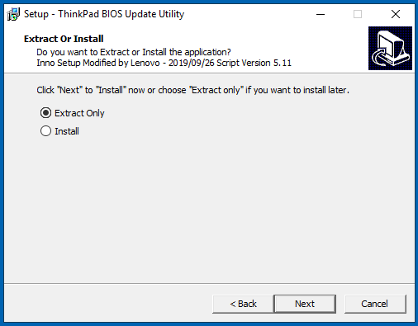
- Colocamos el fichero logo.jpg en el directorio. Si no lo ha generado el instalador, se ha de hacer a mano:
C:\DRIVERS\FLASH\r1uuj23ww\...\Rfs\StartupImages
- Ejecutamos el fichero WINUPTP.exe. El sistema realizará la actualización de la BIOS.
(ruta C:\DRIVERS\FLASH\r1uuj23ww\...).
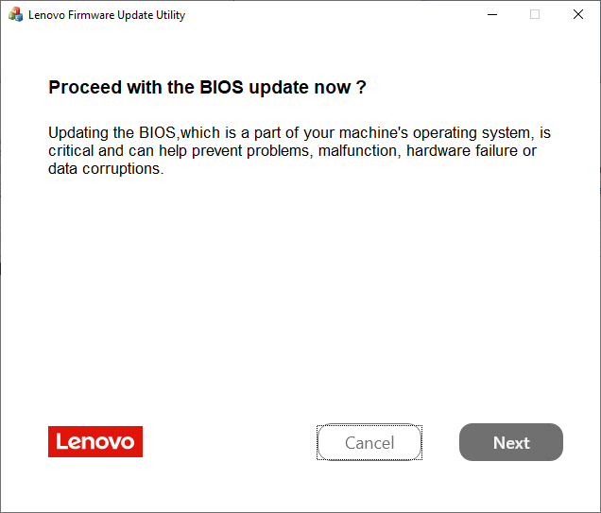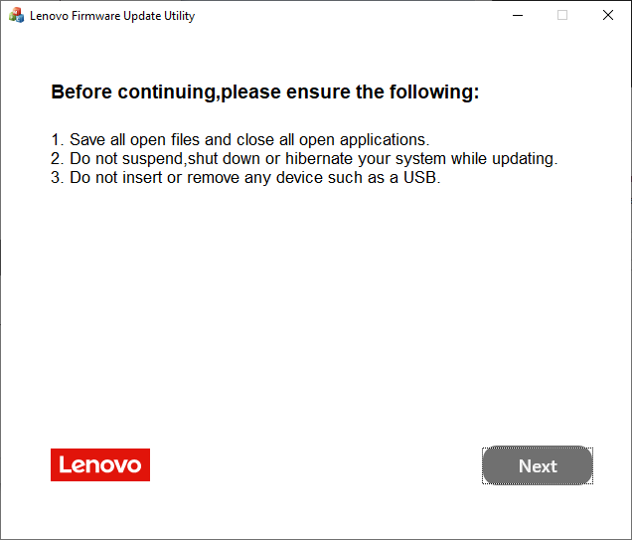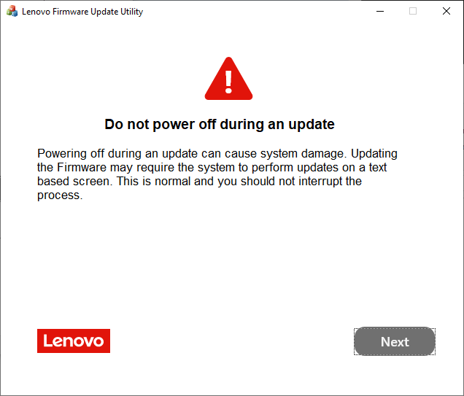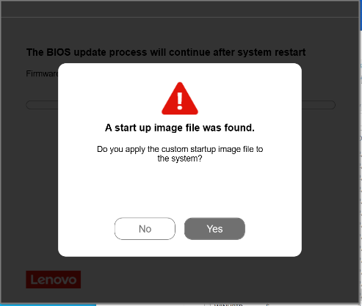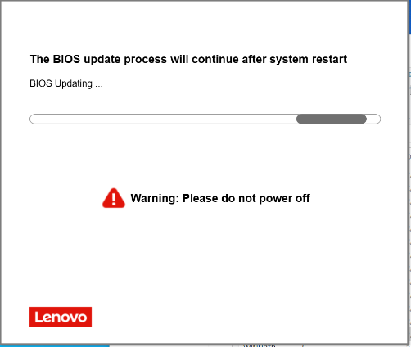

Package | BIOS | (BIOS ID) | ECP | (ECP ID) | Rev. | Issue Date
R1UUJ23WW | 1.31 | (R1UET55W) | 1.18 | (R1UHT39W) | 01 | 2026/04/13

Una vez finalizado, el sistema se reinicia. Dejamos que finalicen los trabajos de actualización.
Una vez dentro de Windows, eliminamos la carpeta generada (C:\Drivers\....\ ).

Carga de valores.
- Ejecutamos fichero ThinkBiosConfig.
- Seleccionamos el fichero *.ini del producto que queremos configurar y pulsamos en ejecutar.
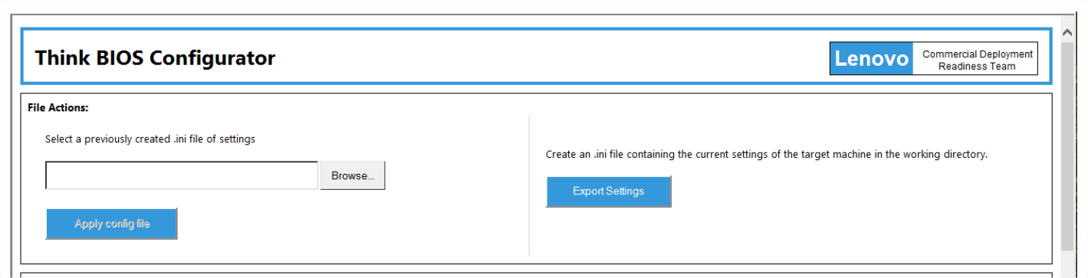
- El sistema nos dirá que tras el reinicio se aplicarán los cambios.

Summary of Changes:
<R1UUJ23WW>
UEFI: 1.31 / ECP: 1.18
- [Important] Enhancement to address security vulnerability, CVE-2025-2295.
- [Important] Enhancement to address security vulnerability, CVE-2025-3052.
- [Important] Enhancement to address security vulnerability, CVE-2025-31648.
- [Important] Enhancement to address security vulnerability, CVE-2025-10237.
- [Important] Enhancement to address security vulnerability, CVE-2025-10238.
- (New) Updated the Diagnostics module to version v04.43.000.
- (New) Updated the new Root CA for Lenovo Cloud.

<R1UUJ22WW>
UEFI: 1.29 / ECP: 1.17
- [Important] Enhancement to address security vulnerability, CVE-2025-20064.
- [Important] Enhancement to address security vulnerability, CVE-2024-7344.
- [Important] Enhancement to address security vulnerability, CVE-2024-38805.
- (New) Updated the Diagnostics module to version v04.39.000.

<R1UUJ21WW>
UEFI: 1.28 / ECP: 1.17
- [Important] Enhancement to address security vulnerability, CVE-2025-20103, CVE-2025-20054.
- [Important] Enhancement to address security vulnerability, CVE-2024-38796.
- [Important] Enhancement to address security vulnerability, CVE-2025-20109.
- [Important] Enhancement to address security vulnerability, CVE-2024-45332.
- [Important] Enhancement to address security vulnerability, CVE-2024-12533.
- [Important] Enhancement to address security vulnerability, LEN-167098.
- [Important] Enhancement to address security vulnerability, CVE-2023-48267, CVE-2023-49603, CVE-2023-49615, CVE-2023-49618, CVE-2024-36262, CVE-2023-48366.
- (Fix) Fixed an issue that system cannot enter UC mode when running Zoom or Teams.

<R1UUJ20WW_V3>
UEFI: 1.27 / ECP: 1.16
- [Fix] Fixed an issue that Windows may occur BSOD while updating BIOS on 24H2.

<R1UUJ20WW_V2>
UEFI: 1.27 / ECP: 1.16
- Withdrawn due to BSOD on 24H2.
- [Important] Fixed an issue where BIOS Update Utility will be blocked by Microsoft "Vulnerable Driver Blocklist”.

<R1UUJ20WW>
UEFI: 1.27 / ECP: 1.16
- [Important] Enhancement to address security vulnerability, CVE-2024-24582.
- [Important] Enhancement to address security vulnerability, CVE-2024-1298.
- (New) Updated the Diagnostics module to version v04.36.000.
- (Fix) Fixed an issue that touchpad doesn't work in pre-boot authentication application.

<R1UUJ19WW_V2>
UEFI: 1.26 / ECP: 1.16
- (New) Updated WinFlash package to create log file.

<R1UUJ19WW>
UEFI: 1.26 / ECP: 1.16
- [Important] Enhancement to address security vulnerability, CVE-2023-45236, CVE-2023-45237.
- [Important] Enhancement to address security vulnerability, CVE-2024-31068.
- (New) Supported Wifi-6E in TW.
- (Fix) Fixed an issue that BIOS UI is freezing on Secure Boot Key page.
- (Fix) Fixed an issue that BIOS may enter PXE boot loop.

<R1UUJ18WW>
UEFI: 1.25 / ECP: 1.16
- [Important] Enhancement to address security vulnerability, LEN-154756.
- [Important] Enhancement to address security vulnerability, LEN-148267.
- [Important] Enhancement to address security vulnerability, CVE-2024-24968
- [Important] Enhancement to address security vulnerability, CVE-2023-41833, CVE-2023-23904, CVE-2023-22351, CVE-2023-25546.
- (New) Updated the Diagnostics module to version v04.35.001.
- (New) Updated ESRT to support new MEFW 16.1.32.2418.
- (New) Supported Wifi-6E in Canada.
- (Fix) Fixed an issue that the automatic repair screen appears when performing
Exit Discarding Changes "No" Button.

<R1UUJ17WW>
UEFI: 1.23 / ECP: 1.14
- [Important] Enhancement to address security vulnerability, CVE-2023-45733, CVE-2023-49141, CVE-2023-45229, CVE-2023-45230, CVE-2023-45231, CVE-2023-45232, CVE-2023-45233, CVE-2023-45234, CVE-2023-45235,CVE-2023-45236, CVE-2023-45237, CVE-2023-27504, CVE-2023-28402, CVE-2023-28383, CVE-2022-21894, CVE-2023-24932.
- (New) Updated the Diagnostics module to version v04.33.000.
- (New) Updated Microsoft CA certificate.

<R1UUJ16WW>
UEFI: 1.22 / ECP: 1.14
- (New) Support new WMI: ChargeInBatteryMode.
- (New) Updated PD Firmware to F609.06.13.

<R1UUJ15WW>
UEFI: 1.21 / ECP: 1.13
- [Important] Enhancement to address security vulnerability, CVE-2023-23583, CVE-2023-28746,
CVE-2023-39368, CVE-2023-38575, CVE-2023-32282.
- (New) Update the CPU microcode.
(Note) Above update will show "BIOS Self Healing backup progressing"
message and bar on screen during BIOS update process.
- (New) Updated Diagnostics to v04.32.000.
- Fixed an issue that BIOS still shows Wireless WAN option in Setup menu without WWAN Card.
- Fixed an issue where system might take a minute to boot when user attached Docking/Monitor with Realtek USB Ethernet device.

<R1UUJ14WW>
UEFI: 1.20 / ECP: 1.13
- [Important] Enhancement to address security vulnerability, CVE-2023-5058.

<R1UUJ13WW>
UEFI: 1.19 / ECP: 1.13
- (New) Updated the CPU microcode.
(Note) Above update will show "BIOS Self Healing backup progressing"
message and bar on screen during BIOS update process.
- (New) Update FMP driver of Goodix touch pad.
- (New) Updated Regulatory Information.
- (Fix) Thermal improvement for FAN control.
- (Fix) Fixed an issue where Linux console displayed PCI error.
- (Fix) Fixed an issue where BIOS POST took longer boot time when a DisplayLink Dock is attached.
- (Fix) Updated some BIOS Setup help messages.

<R1UUJ12WW>
UEFI: 1.18 / ECP: 1.12
- (Fix) Fixed an issue where Dock power button override is working during firmware update.

<R1UUJ11WW>
UEFI: 1.17 / ECP: 1.11
- (Fix) Fixed an issue that Bison camera flicker in Zoom.

<R1UUJ10WW>
UEFI: 1.16 / ECP: 1.11
- [Important] Enhancement to address security vulnerability, CVE-2021-35878, CVE-2021-42299.
- (New) Update Diagnostics to v04.31.000
- (Fix) Fixed an issue where USB-C/Thunderbolt port and charging function become
unavailable rarely.

<R1UUJ09WW>
UEFI: 1.15 / ECP: 1.10
- [Important] Enhancement to address security vulnerability, CVE-2023-3110,
CVE-2022-4304, CVE-2022-40982, CVE-2023-28005, CVE-2022-36763,
CVE-2022-36764, CVE-2022-36765.
- (New) Update Realtek WLAN UNDI driver to ver2.040.
- (New) Update Intel WLAN UNDI driver.
- (New) Update Diagnostics to v04.30.000.
- (New) Update PD firmware F609.06.11.
- (New) Updated the CPU microcode.
(Note) Above update will show "BIOS Self Healing backup progressing"
message and bar on screen during BIOS update process.
- (Fix) Fixed an issue Reset loop when ME capsule update failure.
- (Fix) Fixed an issue Unit may not resume from sleep.
- (Fix) Fixed an issue where NVMe passwords could not be erased properly.

<R1UUJ08WW>
UEFI: 1.14 / ECP: 1.09
- [Important] Enhancement to address security vulnerability, CVE-2022-48189.
- (New) Updated the CPU microcode.
(Note) Above update will show "BIOS Self Healing backup progressing"
message and bar on screen during BIOS update process.
- (Fix) Fixed an issue where abnormal shutdown may be logged when Thunderbolt device
is attached or detached while system is in shutdown state.
- (Fix) Fixed an issue where LCD screen goes black after unplugging docking station in BIOS Setup.
- (Fix) Fixed an issue system may not wake up from sleep by Fn key.
- (Fix) Hide text cursor before leaving Boot Menu.

<R1UUJ07WW>
UEFI: 1.13 / ECP: 1.08
- (Fix) Fix trackpoint/FingerPrinter no function on POST.
- (Fix) Removed EventLog record bottom cover tamper log.

<R1UUJ06WW>
UEFI: 1.12 / ECP: 1.07
- (New) Update thermal table for new SSD WD-SN740.
- (Fix) Fix an issue that setup menu may have garbge if press hotkey.

<R1UUJ05WW>
UEFI: 1.11 / ECP: 1.06
- [Important updates] Enhancement to address security vulnerability, CVE-2022-34301, CVE-2022-34302, CVE-2022-34303.
- (New) Add SK Hynix new die 1znm DDR4 8Gbx16 Component.
- (New) Update new SSD DITT and DPTF parameters.
- (New) Update RtkUsbUndiDxe.2.039.2022.08.15.efi.
- (New) Update Diagnostics to v04.27.000.
- (Fix) Fixed an issue where it may take around 2 minutes to boot after forcedly shutdown
- (Fix) Fixed an issue where system may hang at POST if Fingerprint Reader function is disabled in BIOS Setup.

<R1UUJ04WW>
UEFI: 1.10 / ECP: 1.06
- [Important] Update TrackPoint FMP driver.
- [Important] Update Diagnostics to v04.27.000.
- [Important] Update Intel GOP driver to 21.0.1059.
- [Important] Update E-label to v6.1.0.25.

<R1UUJ03WW>
UEFI: 1.07 / ECP: 1.04
- (Fix) Disable SHA384 Support.

<R1UUJ02WW>
UEFI: 1.05 / ECP: 1.04
- [Important] Update WLAN 6E settings.
- [Important] Update Intel GOP driver to 21.0.1050
- (Fix) Fixed SMBIOS TYPE 2 (BASEBOARD INFORMATION) error.

